**M.I.T. LAB Assignment – 05**

**U19CS012**

(1) Write a program to Add ten 8-bit numbers stored in memory starting from 3000H.Store your result at 3050H.

Notepad Code:

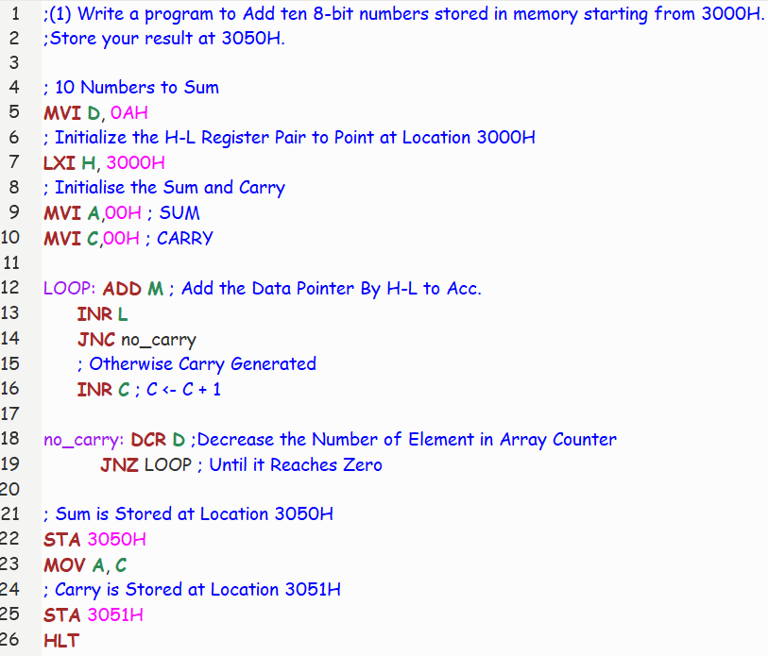

Registers and Memory:

Eg : (1) Array = [1, 1, 1, 1, 1, 1, 1, 1, 1, 1]

Sum of Array Elements = 10 = (0A)H

Sum = (0A)H = 10 [Location 3050H] & Carry = (00)H = 0 [Location 3051H]

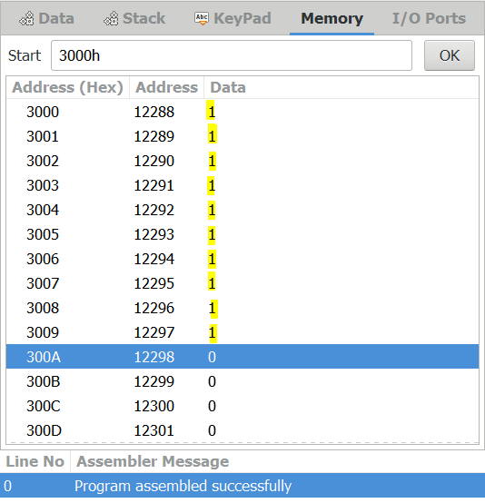 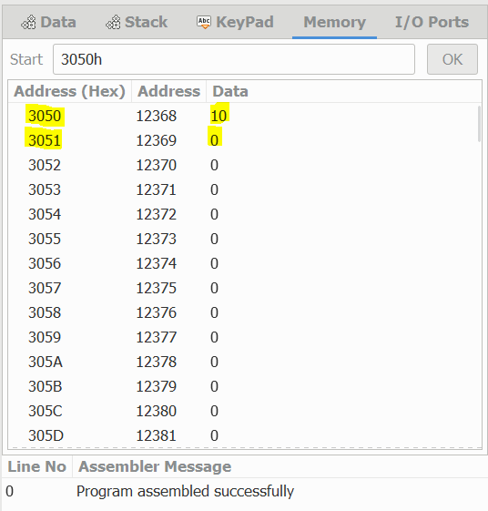

(2) Array = [250, 250, 1, 1, 1, 1, 1, 1, 1, 1]

Sum of Array Elements = 508 = (1FC)H

Sum = (FC)H = 252 [Location 3050H] & Carry = (01)H = 1 [Location 3051H]

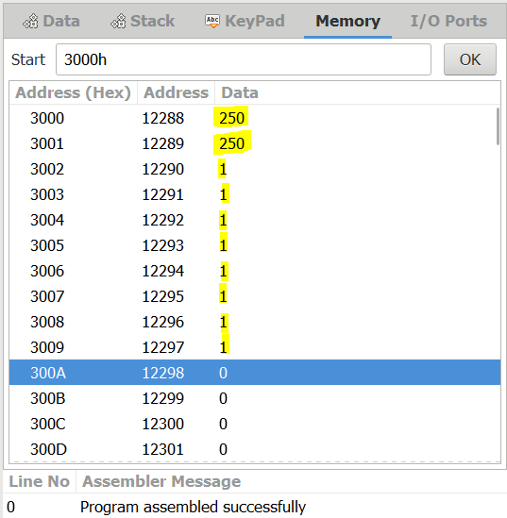 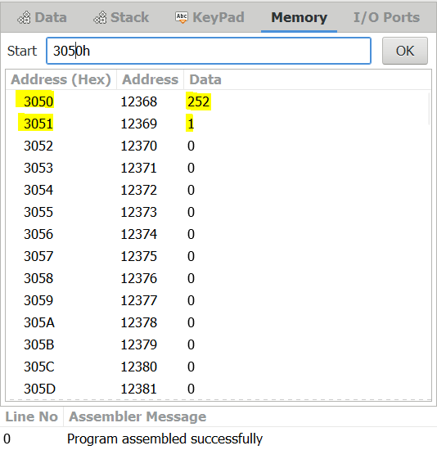

(2) Write a program to find smallest/largest number from the array of 8-bit data. Assume suitable memory location for data and result.

Notepad Code:

(A) Largest Element in Array

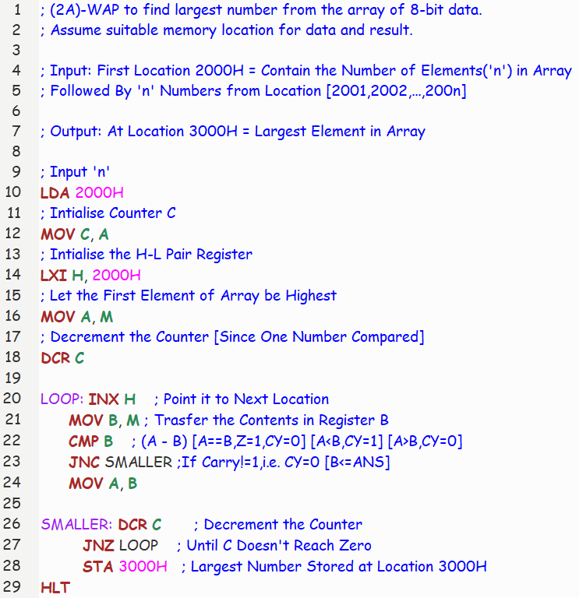

Registers and Memory [Largest Number Code]:

Eg : Array of 10 Numbers = [1, 23, 12, 17, 91, 7, 22, 66, 81, 44]

Largest Element in Array = 91

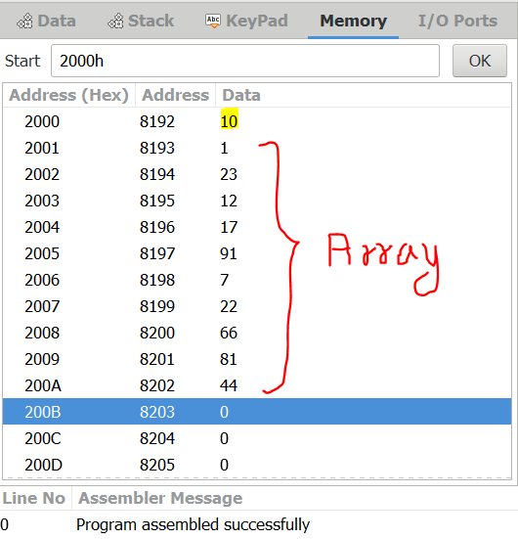 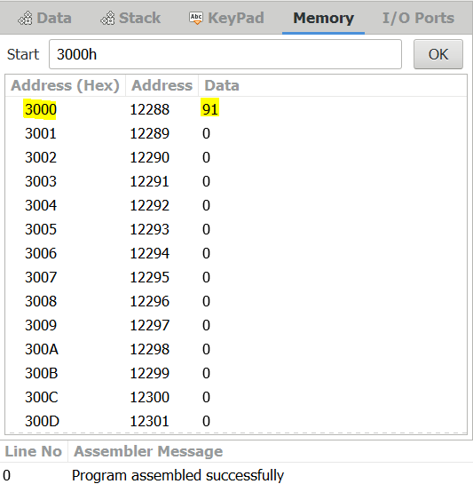

Registers and Memory [Smallest Number Code]:

Eg : Array of 10 Numbers = [1, 23, 12, 17, 91, 7, 22, 66, 81, 44]

Smallest Element in Array = 1

 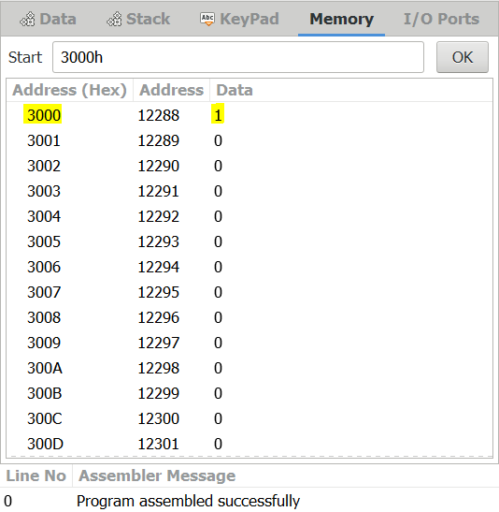

(B) Smallest Element in Array

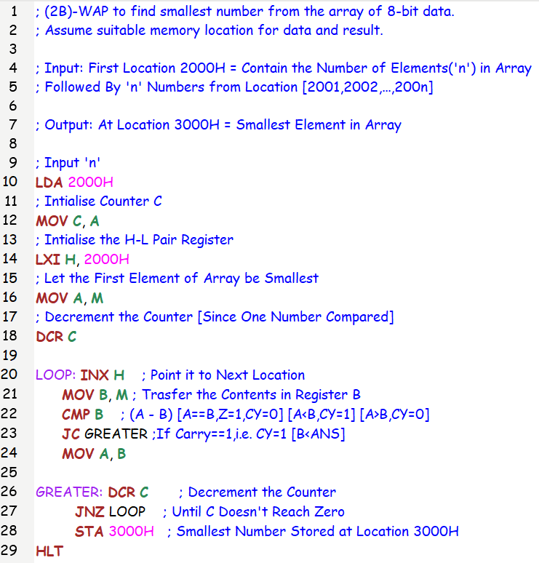

Exampled Attached above Code.

(3) Write a Program to search an 8-bit number from the array of 8-bit data.

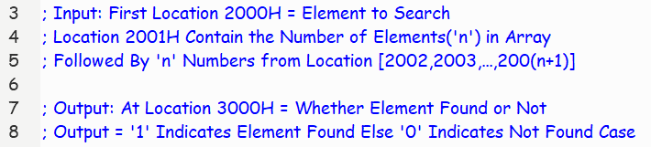

Notepad Code:

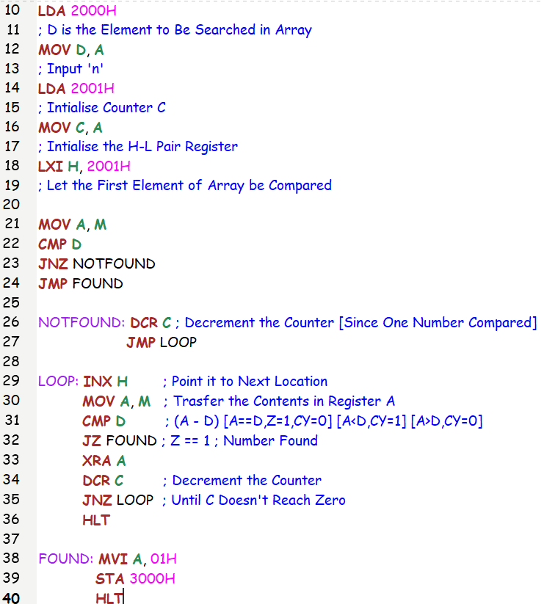

Registers and Memory:

Lets Check for 10 [Element in Array]

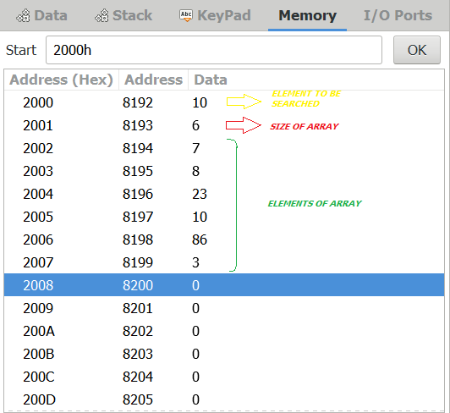 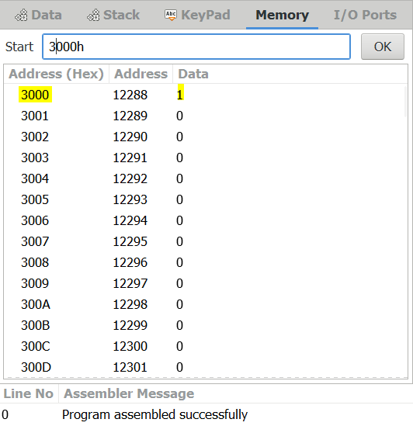

Lets Now Check for 9 [Element Not in Array]

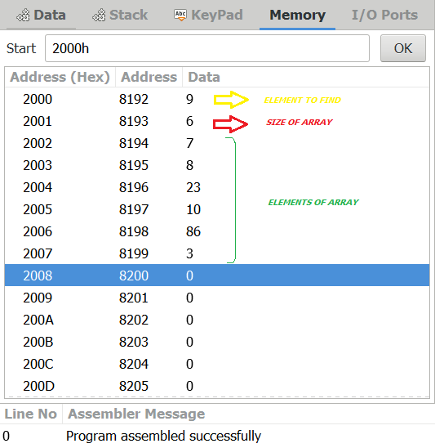 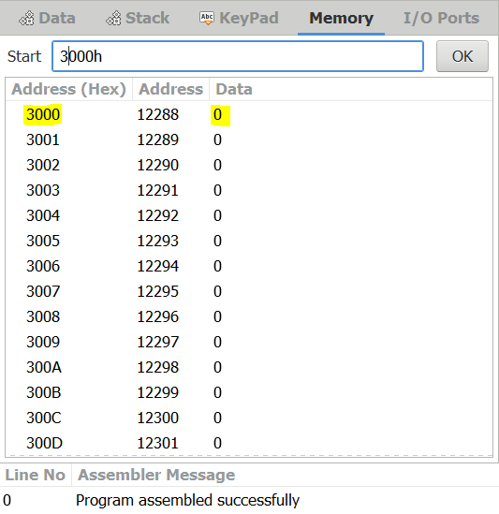

(4) Write a Program to arrange data in ascending/descending order. Assume suitable memory location for data and result.

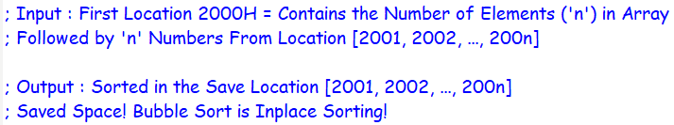

Notepad Code [Ascending Order]:

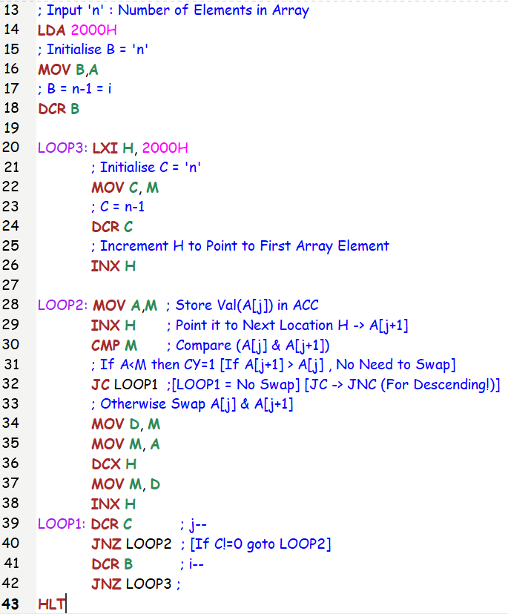

Registers and Memory:

A.) Registers and Memory [Ascending Order]:

Eg:

**Input**: Array of 6 Numbers = [45, 12, 87, 4, 16, 34]

**Output**: Array = [4, 12, 16, 34, 45, 87]

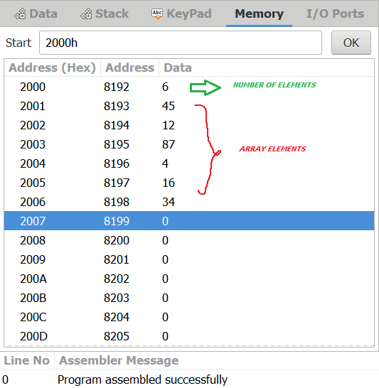 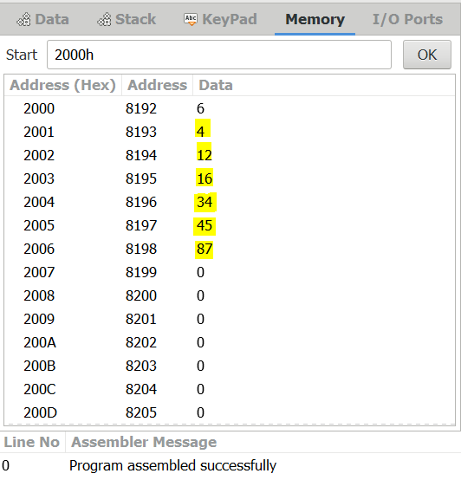

Notepad Code [Descending Order]:

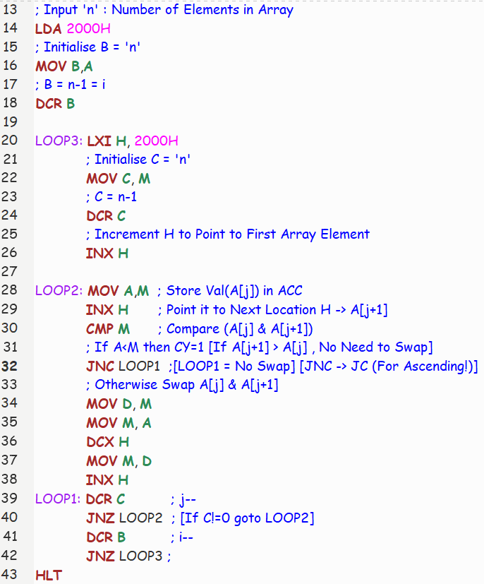

Registers and Memory [Descending Order]:

Eg:

**Input**: Array of 6 Numbers = [45, 12, 87, 4, 16, 34]

**Output**: Array = [87, 45, 34, 16, 12, 4]

 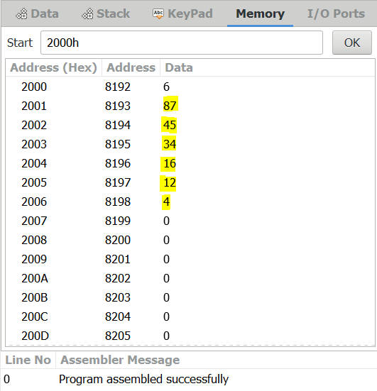

SUBMITTED BY:

BHAGYA VINOD RANA

[***U19CS012***]